

**EE-222: Microprocessor Systems**

**Project Report**

**Web-Controlled  
Multifunctional Car**



**Group Members**

|  |  |
| --- | --- |
| **Name** | **Reg. No** |
| Muhammad Ahmed Mohsin | 333060 |
| Muhammad Umer | 345834 |
| Tariq Umar | 334943 |

**Table of Contents**

Abstract 3

Literature Review 3

Diagram 4

Block Diagram 5

Schematic 6

Design Methodology 6

* Web Sever / Local Host 6
* L298 Motor Driver 7

Module Descriptions 7

* ATMega 7
* IR Sensors 7
* Ultrasonic Sensor 7
* DC Motors 8

.INO Codes 9

* NodeMCU 9
* ATMega16A 12

Android Application (.apk) 13

Hardware Simulation (.gif) 14

Conclusion 15

Future Prospects 15

# Abstract

In this project, we aim to develop a Web-Controlled Multifunctional Car. We hope to implement features such as line following, obstacle detection etc. along with some specialized features such as light sensors and buzzers. All of this will be implemented with an ATMEL microcontroller as the heart of our project.

Other hardware components will include NodeMCU (ESP8266 Wi-Fi-Module) along with L298 Motor Driver. Moreover, we also aim to develop a mobile app or a website to control the car. Our objective is to develop skills to use microprocessor to implement advanced functions on hardware.

This will give us an insight on how to implement the theoretical knowledge on hardware and what are the difficulties faced during the process. We can further extend our functionality from detection to identification in order to make our car as an information gathering device over a long-ranged Wi-Fi network.

# Literature Review

ATMega16A is a transformative device that has been the brain of countless projects. It has has everything that is required by the user to make it the control board, the heart, of a project. This includes its in-built Analog-to-Digital converter, I/O Ports, Pulse Width Modulation, etc. With the combination of this microcontroller and the WiFi shield, NodeMCU harboring ESP8266, we can gain wireless access of numerous housing appliances, integrate IoT into even the smallest of things, and control it all through smartphones.

According to R. Bhatt and S. Roy, “The Wireless control is one of the most basic of needs for all the people over the globe. But unfortunately the technology is not fully utilized due to a huge amount of data and communication overheads.” The robotics and automation industry which rules the various sectors from manufacturing to household entertainments, is widely used because of its simplicity and its ability to adapt to meet changes of needs.

This project aims to develop an Android application based robotic vehicle for remote operations. It Is to be noted that this serves as a prototype of what could be a much larger model, however, at the expense of communication baud rates and affordability. Another benefit of making such a project is its ability to be flexible and to harbor much more features than is currently present.

Researchers at nVidia made one such model that is able to traverse a room, avoiding all obstacles, while getting a high definition video capture that is then passed through a powerful machine learning algorithm to model the entirety of the room, including all the objects within it, with high precision, all through a single video capture.

# Diagram

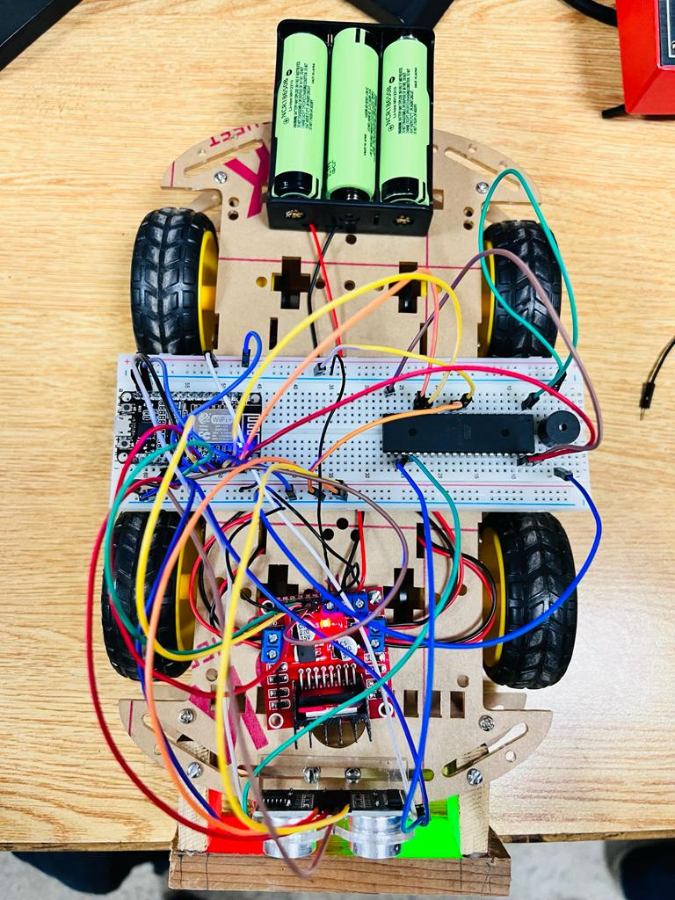

Practical Model

# Block Diagram

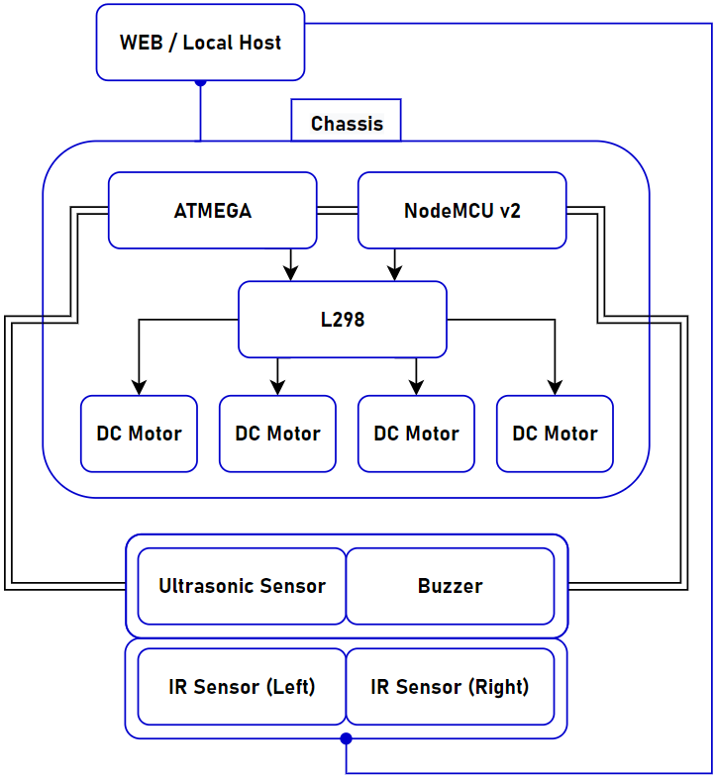

*The proposal-phase block diagram of our WiFi Controlled Multifunctional Car. It is to be note that the attached block diagram does not depict any logical or control flow, as it solely was to provide the authors of this report a base to kickstart their projects. Logical arguments and relevant subchanges were made along the making of the robotic car. The following figure, the schematic, provides a much detailed connection of how all the modules shown above are connected.*

# Schematic

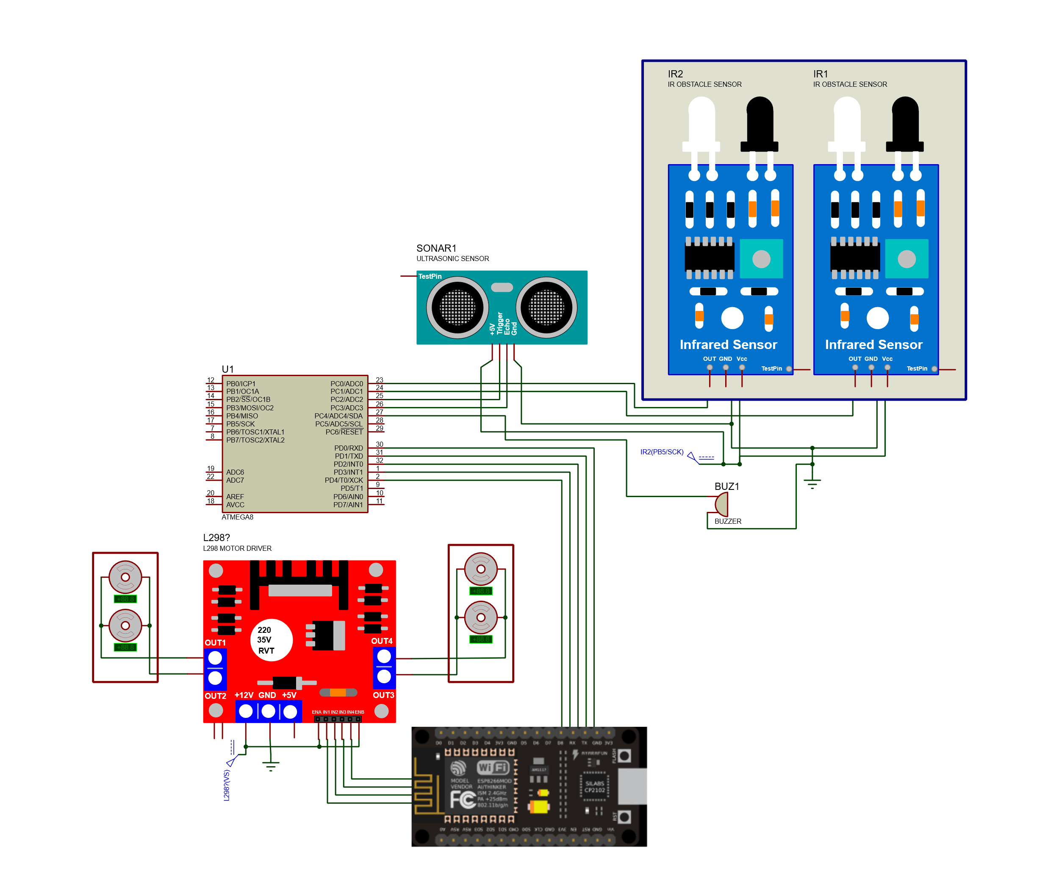

# Design Methodology

## Web Sever / Local Host

**NodeMCU**is a low-cost open source [IoT](https://en.wikipedia.org/wiki/Internet_of_Things) platform. It initially included [firmware](https://en.wikipedia.org/wiki/Firmware) which runs on the [ESP8266](https://en.wikipedia.org/wiki/ESP8266) [Wi-Fi](https://en.wikipedia.org/wiki/Wi-Fi) [SoC](https://en.wikipedia.org/wiki/System_on_a_chip) from [Espressif](https://en.wikipedia.org/w/index.php?title=Espressif&action=edit&redlink=1) Systems, and hardware which was based on the ESP-12 module. Later, support for the [ESP32](https://en.wikipedia.org/wiki/ESP32) 32-bit MCU was added. We used the Web Server / Local host and used its in built Wi-Fi module to connect with the APK installed in our phones and generate a local IP address which then helped in performing distinct functions built through the cellphone application.

## L298 Motor Driver

This **L298N Motor Driver Module** is a high power motor driver module for driving DC and Stepper Motors. This module consists of an L298 motor driver IC and a 78M05 5V regulator. **L298N Module** can control up to 4 DC motors, or 2 DC motors with directional and speed control. We used this module to drive our motors and to perform basic functions like move forward, backward, etc. It is used to control the motors and the movement of the car to perform different web controlled functions.

# Module Descriptions

## ATMega

The ATmega16A is a low-power CMOS 8-bit microcontroller based on the Atmel AVR enhanced RISC architecture. By executing powerful instructions in a single clock cycle, the ATmega16A achieves throughputs approaching 1MIPS per MHz allowing the system designer to optimize power consumption versus processing speed. It was basically used to send signals to the sensors in our project. The Atmega16 was coded and burnt and then was used to send signals and instructions to the sensors.

## IR Sensors

**Infrared Sensor Module** has built-in **IR transmitter and IR receive**r that sends out IR rays and looks for reflected IR rays to detect presence of any obstacle in front of the sensor module.IR sensors were used to implement the function of line following. Both the sensors were place with an equal distance from the ground and with the same sensitivity and with the help of both of them we implemented line tracking system. This line tracking system was in built in the application as well.

## Ultrasonic Sensor

SR-04 Ultrasonic Sensor Module is a 4 - pin module, pin names are Vcc, Trigger, Echo and Ground respectively.

Distance = Speed × Time

**HC-SR04 Ultrasonic (US) sensor** is a 4 pin module, whose pin names are Vcc, Trigger, Echo and Ground respectively. This sensor is a very popular sensor used in many applications where measuring distance or sensing objects are required. The module has two eyes like projects in the front which forms the Ultrasonic transmitter and Receiver.

We used this sensor for obstacle avoidance. The code was built such that at a distance of about 15cm from the obstacle and then rotates 90 degrees to the left and starts moving. When it detects the object it stops and then a beep from buzzer is played then the car rotates 90 degrees and then starts moving.

## DC Motors

This **Micro DC Gear Motor** with Shaft is ideal for DIY enthusiasts and is designed to easily incorporate the encoder. These motors are inexpensive, small, easy to install, and ideally suited for use in a mobile robot car. These motors are controlled by L298 motor driver where two motors each are connected in common and the functionality and operation of these motors are controlled by the motor driver.

|  |
| --- |
| **Functionality** |
| Line Following |
| Web – Controlled Movement |
| Obstacle Detection & Avoidance |

|  |
| --- |
| **Components** |
| ATMEGA 8/16 |
| NodeMCU V2 (ESP8266) |
| L298N Motor Driver |
| 4 x DC Motors |
| 3 x Li-Ion Batteries (3.3V) |
| Breadboard |
| Car Chassis |
| Buzzer |
| 2 x IR Sensor |
| Ultrasonic Sensor |

|  |
| --- |
| **Relevant Industries** |
| LRRC Robotics |
| IoT (Internet of Things) |
| Information Nodes |

# .INO Codes

## NodeMCU

**#define IN_1 D8 // L298N in1 motors Rightx GPIO15(D8)**

**#define IN_2 D7 // L298N in2 motors Right GPIO13(D7)**

**#define IN_3 D4 // L298N in3 motors Left GPIO2(D4)**

**#define IN_4 D3 // L298N in4 motors Left GPIO0(D3)**

**#define TRIG_SIGNAL D5**

**#define ECHO D6**

**#define LT1 D2**

**#define LT2 D1**

**#define LT_SIGNAL D0**

**#include <ESP8266WiFi.h>**

**#include <WiFiClient.h>**

**#include <ESP8266WebServer.h>**

**/* data received from application */**

**String data = "";**

**int speedCar = 400; // 400 - 1023.**

**int speed_Coeff = 3;**

**long duration;**

**int distance;**

**/* define port */**

**ESP8266WebServer server(80);**

**/* WIFI settings */**

**const char* ssid = "Car";**

**void setup() {**

**Serial.begin(115200);**

**pinMode(TRIG_SIGNAL, OUTPUT);**

**pinMode(ECHO, INPUT);**

**pinMode(IN_1, OUTPUT);**

**pinMode(IN_2, OUTPUT);**

**pinMode(IN_3, OUTPUT);**

**pinMode(IN_4, OUTPUT);**

**pinMode(LT1, INPUT);**

**pinMode(LT2, INPUT);**

**WiFi.mode(WIFI_AP);**

**WiFi.softAP(ssid);**

**//**

**IPAddress myIP = WiFi.softAPIP();**

**Serial.print("AP IP address: ");**

**Serial.println(myIP);**

**// Starting WEB-server**

**server.on ( "/", HTTP_handleRoot );**

**server.onNotFound ( HTTP_handleRoot );**

**server.begin();**

**}**

**void goBack(){**

**digitalWrite(IN_1, LOW);**

**digitalWrite(IN_2, HIGH);**

**digitalWrite(IN_3, LOW);**

**digitalWrite(IN_4, HIGH);**

**}**

**void goAhead(){**

**digitalWrite(IN_1, HIGH);**

**digitalWrite(IN_2, LOW);**

**digitalWrite(IN_3, HIGH);**

**digitalWrite(IN_4, LOW);**

**}**

**void goRight(){**

**digitalWrite(IN_1, HIGH);**

**digitalWrite(IN_2, LOW);**

**digitalWrite(IN_3, LOW);**

**digitalWrite(IN_4, HIGH);**

**}**

**void goLeft(){**

**digitalWrite(IN_1, LOW);**

**digitalWrite(IN_2, HIGH);**

**digitalWrite(IN_3, HIGH);**

**digitalWrite(IN_4, LOW);**

**}**

**void stopRobot(){**

**digitalWrite(IN_1, LOW);**

**digitalWrite(IN_2, LOW);**

**digitalWrite(IN_3, LOW);**

**digitalWrite(IN_4, LOW);**

**}**

**void lineTracker(){**

**digitalWrite(LT_SIGNAL, HIGH);**

**//line detected by both**

**if(digitalRead(LT1)==0 && digitalRead(LT2)==0){**

**//Forward**

**goAhead();**

**}**

**//line detected by left sensor**

**else if(digitalRead(LT1)==0 && !digitalRead(LT2)==0){**

**//turn left**

**goLeft();**

**}**

**//line detected by right sensor**

**else if(!digitalRead(LT1)==0 && digitalRead(LT2)==0){**

**//turn right**

**goRight();**

**}**

**//line detected by none**

**else if(!digitalRead(LT1)==0 && !digitalRead(LT2)==0){**

**//stop**

**stopRobot();**

**}**

**digitalWrite(LT_SIGNAL, LOW);**

**}**

**void objectAvoid(){**

**digitalWrite(TRIG_SIGNAL, HIGH);**

**delayMicroseconds(13);**

**duration = pulseIn(ECHO, HIGH);**

**distance = duration * 0.034 / 2;**

**Serial.print(distance);**

**if (distance <= 15){**

**stopRobot();**

**delay(500);**

**goLeft();**

**delay(500);**

**}**

**else {**

**goAhead();**

**}**

**digitalWrite(TRIG_SIGNAL, LOW);**

**}**

**void loop()**

**{**

**/* If the server available, run the "checkClient" function */**

**server.handleClient();**

**data = server.arg("State");**

**if (data == "up") goAhead();**

**else if (data == "down") goBack();**

**else if (data == "left") goLeft();**

**else if (data == "right") goRight();**

**else if (data == "stop") stopRobot();**

**else if (data == "linetracker") lineTracker();**

**else if (data == "objectavoid") objectAvoid();**

**else stopRobot();**

**}**

**void HTTP_handleRoot(void) {**

**if( server.hasArg("State") ){**

**Serial.println(server.arg("State"));**

**}**

**server.send ( 200, "text/html", "" );**

**delay(1);**

**}**

## ATMega16A

**#define F_CPU 1000000UL**

**#include <avr/io.h>**

**#include <util/delay.h>**

**#include <avr/sfr_defs.h>**

**void objectAvoid();**

**void lineTracker();**

**int main()**

**{**

**DDRA = *0b11111100*;**

**DDRC = 0x00;**

**DDRD = 0xFF;**

**while (1) {**

**if ((PINA & (*0b00000001*))) // && !(PINA & (0b00000010))**

**{**

**objectAvoid();**

**}**

**if ((PINA & (*0b00000010*))) // && !(PINA & (0b00000001))**

**{**

**lineTracker();**

**}**

**}**

**}**

**void objectAvoid(){**

**PORTD = *0b00000000*;**

**_delay_us(2);**

**PORTD = *0b00000001*;**

**_delay_us(10);**

**PORTD = *0b00000000*;**

**}**

**void lineTracker(){**

**//line detected by both**

**if(!(PINC & (*0b00000001*)) && !(PINC & (*0b00000010*))){**

**PORTD = *0b00000000*;**

**}**

**//line detected by left sensor**

**else if(!(PINC & (*0b00000001*)) && (PINC & (*0b00000010*))){**

**//turn left**

**PORTD = *0b00000010*;**

**}**

**//line detected by right sensor**

**else if((PINC & (*0b00000001*)) && !(PINC & (*0b00000010*))){**

**//turn right**

**PORTD = *0b00000100*;**

**}**

**//line detected by none**

**else if((PINC & (*0b00000001*)) && (PINC & (*0b00000010*))){**

**PORTD = *0b00000110*;**

**}**

**}**

# Android Application (.apk)

We used open-source MIT App Inventor Platform to create an .apk that is able to send a string of data to an IP Address, which in the current case is the access point generated by the ESP8266 embedded onto the NodeMCU shield. To gain more insight on the development process of the app, two figures have been attached; former of which shows the UI of the built application and the latter shows the logical conditions backing each button / switch.

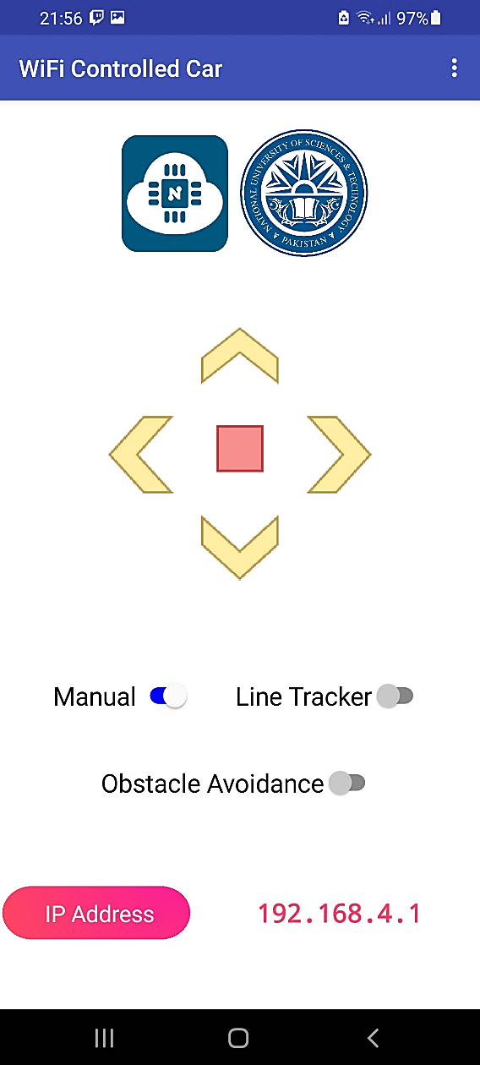

GUI of App

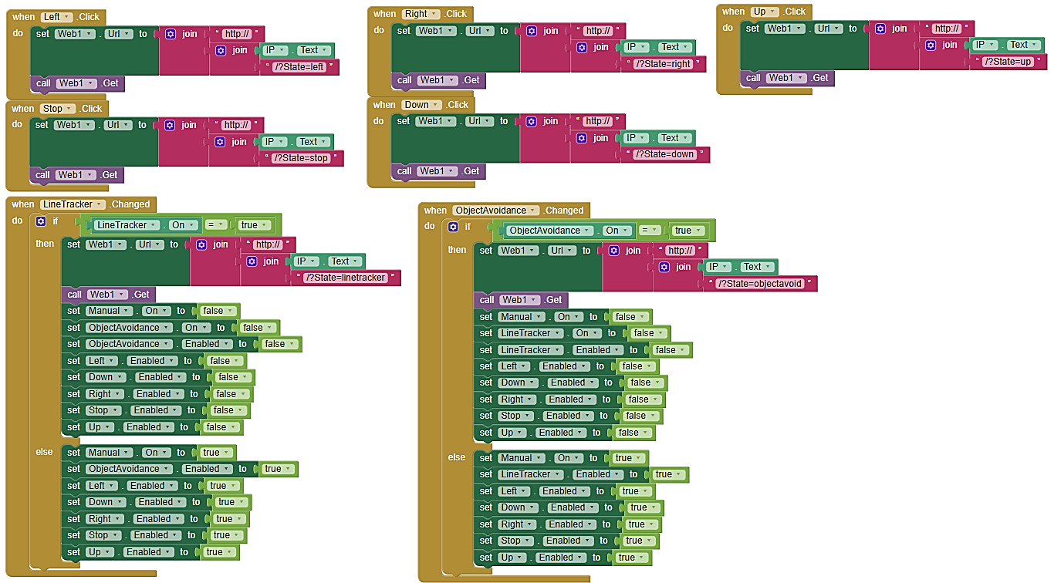

MIT Block Design

# Hardware Simulation (.gif)



# Conclusion

In conclusion,

* In this project we learnt the basics of microprocessor systems and the skills of implementing different microprocessors at the hardware level to build something practical out of it.
* Moreover, we also learnt the basics of different hardware components and learnt their practical implementation.
* The project gave us an insight of how to bring into use the theoretical knowledge and use it along with the hardware.

# Future Prospects

* It developed our interest in this course.
* We learnt about the microprocessor industry and its vast scale.
* Gave us an intuition about the future courses regarding this domain and the research area of the field.